[msuriel6033@CISHavLAMP0 ~]$ vi Trial.sh

[msuriel6033@CISHavLAMP0 ~]$ bash Trial.sh

Hello World

[msuriel6033@CISHavLAMP0 ~]$ mv Trial.sh hello.sh

[msuriel6033@CISHavLAMP0 ~]$ vi echo.sh

[msuriel6033@CISHavLAMP0 ~]$ ./echo.sh

-bash: ./echo.sh: Permission denied

[msuriel6033@CISHavLAMP0 ~]$ chmod 777 echo.sh

[msuriel6033@CISHavLAMP0 ~]$ ./echo.sh

Plain text output of hello variable : Hello World

Semi-opaque text output of hello variable : Hello World

Opaque text output of hello variable : $hello

[msuriel6033@CISHavLAMP0 ~]$ vi echo.sh

[msuriel6033@CISHavLAMP0 ~]$ vi echo.sh

[msuriel6033@CISHavLAMP0 ~]$ ./echo.sh

Plain text output of hello variable : Hello World

Semi-opaque text output of hello variable : Hello World

Opaque text output of hello variable : $hello

[msuriel6033@CISHavLAMP0 ~]$ ls

echo.sh File2 hello.sh Lab0 localfoo1.txt localfoo3.txt

File1 File3 Introduction Lab6 localfoo2.txt

#!/bin/sh

echo "Hello World"

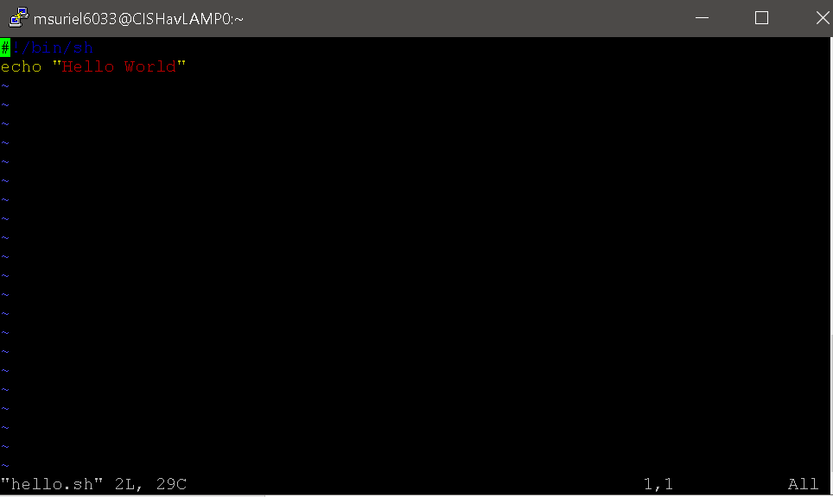‘

#!/bin/sh

# Create a variable that has the text "Hello World"

hello="Hello World"

# Output text and the hello variable to see how plain text handles it

echo Plain text output of hello variable : $hello

# See how semi-opaque output and variables are handled

echo "Semi-opaque text output of hello variable : $hello"

# See how opaque output and variables are handled

echo 'Opaque text output of hello variable : $hello'

